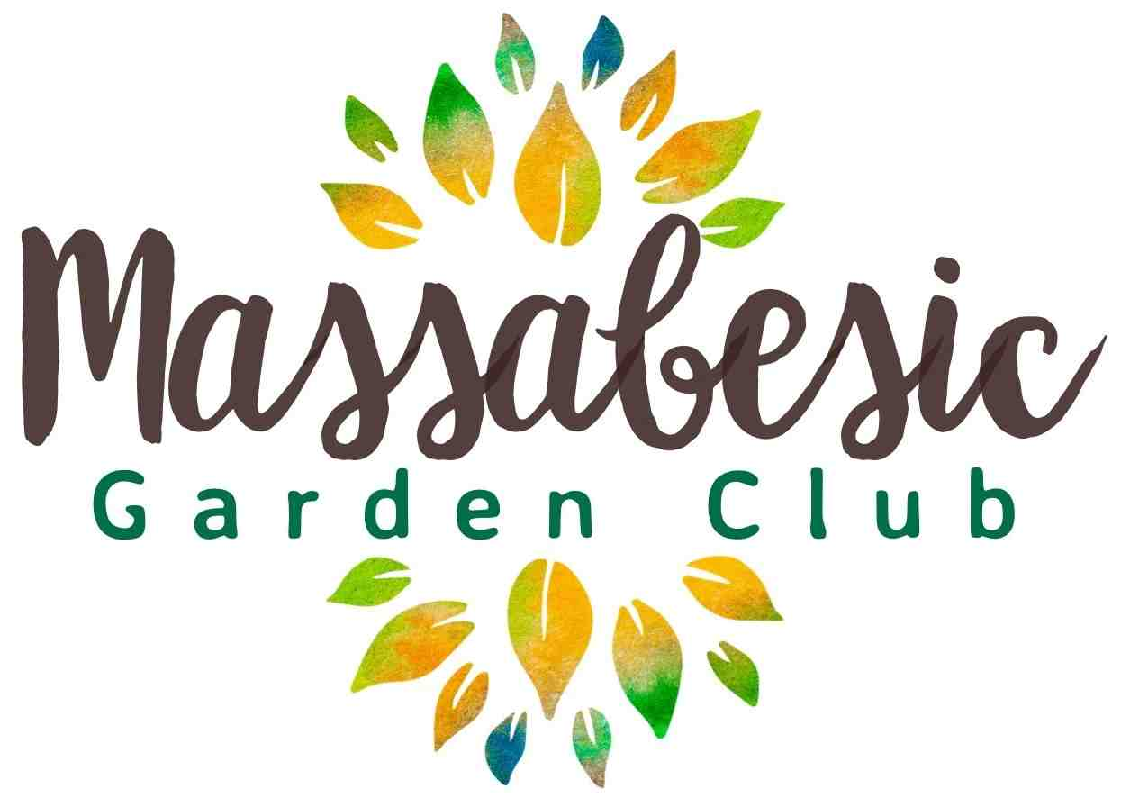

2025/2026 Annual Report
The Massabesic Garden Club Strives to enhance the knowledge and love of gardening through captivating horticulture activities, community events, and information sessions for all ages.
Current Club Officers
Role Name Term Expiration
President Jessica Traynor May 2028
Vice President Jill Jennings May 2026
Treasurer Sharon O’Leary-Graves May 2027
Secretary Caitlyn Folia May 2028
Member At Large Jessica Wallin May 2026
Member at Large Lynn Howard May 2027
Voting to take place at the Annual May 2026 Meeting to elect one Vice President and one Member at Large, each for a 3-year term.
Events & Activities: A Season in Review
- Presentations on the unending Varieties of Daylilies, the Science of Foliage, Pressing & Preserving Flowers, Winter Sowing, Gardening Through All Ages, Composting, and Raised-Bed Gardening
- Auburn Duck Race Mum Sale
- Pansy Bowls from FrizzHome Garden April Fund Raiser
- May 16th MGC/Friends of the Library Plant Sale
- Field Trip to Bedrock Gardens on June 6th

Active Members: 44
2026-2027 MGC Plan
- Auburn Duck Race September 12th – Teacup Succulent Sale
- Grant Applications for future funding
- Speaker topics we hope to cover: Garden Design Masterclass, Mushrooms/foraging, Violets, Garden Tourism, and more!
- Field trip in Spring 2027

